

Mohammad Ali Jinnah University

Chartered by Government of Sindh - Recognized by HEC

**Lab Assignment 3**

**Name:** Muhamad Fahad

**Id:** FA19-BSSE-0014

**Subject:** Software Engineering Lab (CS 3111)

**Section:** CM

**Teacher:** Sir Abdul basit

**Date:** Thursday, October 29, 2020

**Q1. Create level 0 and Level 1 DFDs for the Customer Service System**

**Solution:**

**Level 0**

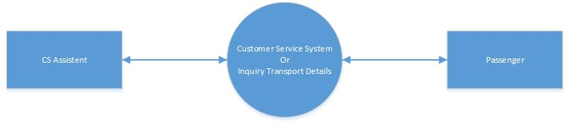

**Level 1**

